Name:

**Lab#4:**

**Ip of** [**www.cengage.com**](http://www.cengage.com)

**Ip of** [**www.msn.com**](http://www.msn.com)

**Changing hosts in Notepad**

**Opening Website**

As you can see website is not opening in my browser because we have resolved it to the msn ip.

**Exercise 2:**

Arp table on my computer

**Default gateway that I recorded is**

**Deleting arp table**



**Creating an automatic entry in arp table of victims computer**

Victims ip

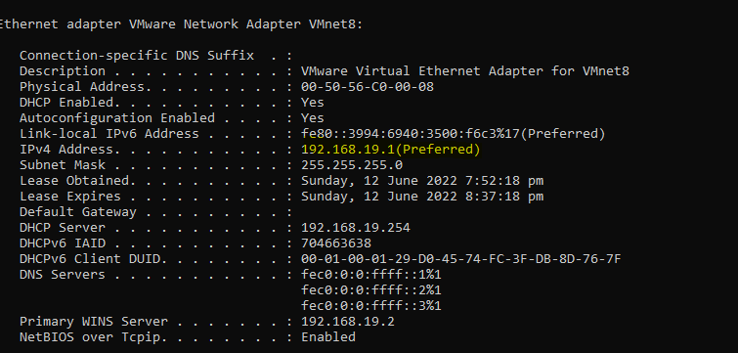

**Pinging victims IP**

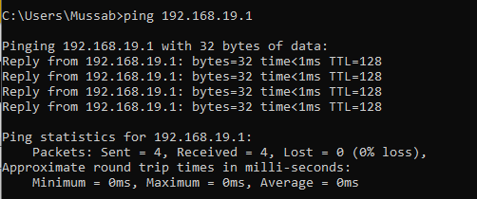

**Verifying it in arp table**

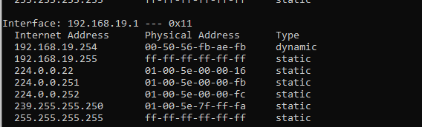

Adding entry to arp table



**Deleting arp entry**



Exercise 3: